August 10, 2021

To whom it may concern:
I am writing to voice my support of Volunteer Energy Cooperative as VEC works to provide broadband internet service to Choose an item. County, TN. There are currently few internet options available in my area, and of the options that are available, the data speeds are very low. To complicate matters, the cell phone service in many parts of the county is spotty, meaning the most rural areas have no digital connectivity whatsoever.
As a resident of Choose an item. County, I am highly in favor of Volunteer Energy providing us with access to broadband internet. I can attest to the hardship the lack of service causes the families of this community. Our children are not able to participate in distance learning, they are not able to conduct adequate research for homework or school projects, and they’re not able to fill out online applications for college scholarships or entrance.
In addition, I myself am not able to work from home, I have no access to telemedicine, and I cannot utilize the internet for any online retail. Any time I need digital access, I have to utilize the internet at work, which is frowned upon by my employer, I have to drive to a retailer with a free hotspot, or I have to try using the browser on my phone, which is belabored at best.
I believe access to broadband internet is no longer an amenity, but rather a necessity. It will not only enhance the quality of life in the community, but it will also serve as an avenue to connect us with the digital resources that we are now missing.
I strongly encourage you to approve the grant request that Volunteer Energy has submitted on the behalf of Choose an item. County.
Thank you.

______________________________________________
Signature

______________________________________________
Address

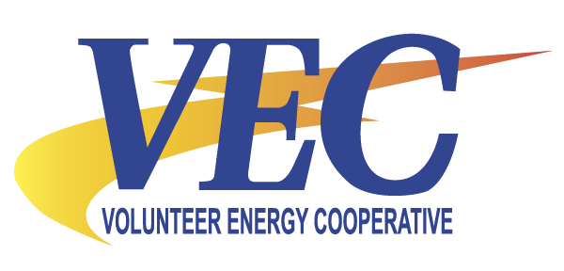Broadband Availability Verification Form

_________________________________
Address Line 1
_________________________________
Address Line 2
_________________________________
City
Tennessee _____________________
State Zip

At the address listed above, we have access to the following internet providers (check all that apply):
☐ AT&T | ☐ Cellular Hotspot
☐ Comcast | ☐ A Satellite Service
☐ Charter/Spectrum | ☐ Other
☐ Frontier | ☐ No Providers Available at this Address

If you already have internet access, please visit www.speedtest.net and run a speed test of your current service and record the upload and download speeds below:
Download: _______________ Mbps
Upload: _______________ Mbps
☐ Not Applicable

Are faster data packages available to you, either through your current provider, or through a different provider to which you do not subscriber?
☐ YES ☐ NO

______________________________________________
Signature

