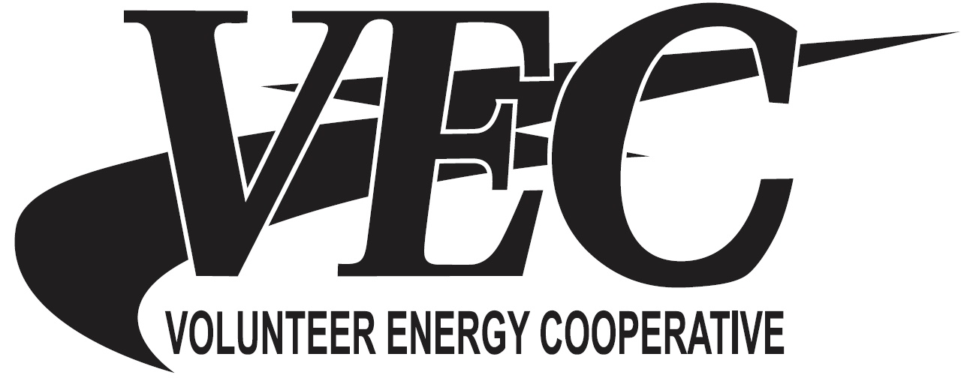
Volunteer Energy Cooperative (VEC), a member owned electric utility, seeks qualified candidates for the position of Lineman – Journeyman or Apprentice (Minimum 3rd Step) in our Crossville/Monterey, Tennessee Service Area. The candidate’s duties include but are not limited to construct and maintain electric power lines and restore power in emergency conditions to the consumers. As such, the Lineman must connect and disconnect electrical equipment on poles of varying heights. The Lineman is required to climb wood poles and operate a bucket truck. A High School Diploma or GED is required. Candidates must have completed a four year apprenticeship or at a minimum be a 3rd Step Apprentice with an approved electric training program. . Knowledge of basic hand and power tools; basic electricity; DOT health card; trouble shooting experience on distribution lines and Commercial Driver’s License Class A with a 57 Restriction is required. Deadline is Wednesday, February 9, 2022. Please submit resume to: VEC, Human Resources, P.O. Box 277, Decatur, Tennessee, 37322, email hrdepartment@vec.org or Fax: 423-334-7102.
Lineman
Journeyman or Apprentice
(Minimum 3rd Step)
All qualified applicants will receive consideration for employment without regard to race, color, religion, sex, sexual orientation, gender identity, age, national origin, disability or veteran status. EOE/Drug Free Workplace.

