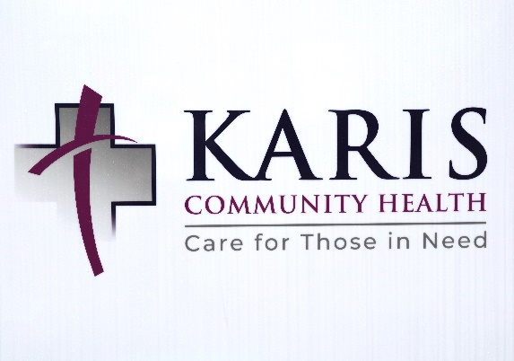
Do you “Share”?
“Following the example of our Lord Jesus Christ by serving others through the provision of quality dental and medical care to low-income adults in our community”: This is the mission of Karis Community Health, a nonprofit dental and medical organization in Bradley County. “Karis,” meaning “grace,” reflects what those at Karis Community Health embody—sharing generosity and love with others.
“We seek to extend God’s grace by providing excellent, yet affordable services to uninsured adults,” said founder and executive director, Kelly Ohlsson.
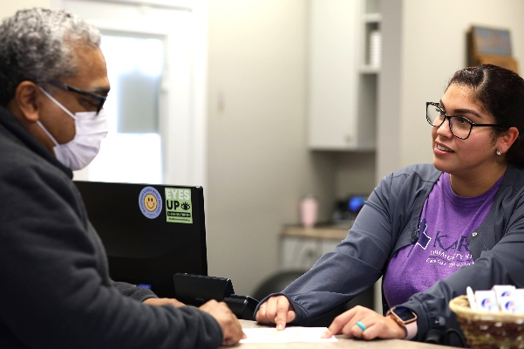
“There has become a great need for dental and medical care in our community. Karis Dental was founded in 2013 in response to efforts by The Caring Place and United Way to address the unmet need of adult dental care in Bradley County. The organization became Karis Community Health about a year ago, after the addition of the medical care facility.”
Karis Community Health provides dental services, check-ups, sick visits, lab and x-ray services and free non-narcotic medications, all from a team of professional clinical staff. In addition, the organization has Spanish-speaking staff members for Hispanic and Latino customers.
Serving 3,700 dental patients and over 450 medical patients, the organization continues to grow. Along with the number of patients growing, so is the need for funds. Ohlsson says because the organization is non-profit, the funds they receive are limited.
Dental Operations Manager Cindy Blair is among those available to speak to Hispanic and Latino customers.
“United Way funds 44% of our needs, everything else comes from donations and/or grants.”
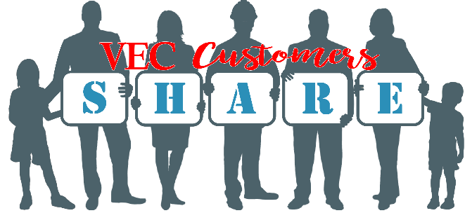
In May 2022, Karis Community Health received a grant from the VEC Customers Share Program. VEC Customers Share is a grant program in which VEC members opt to round their electric bills up to the next whole dollar or, “share.” Although each average VEC member contributes about $6 per year (and never more than $11.88 annually), thousands of dollars each month are distributed to community groups like Karis Community Health.
“We are so thankful for donations and grant programs like VEC Customers Share. As a result of the members’ generosity, we are able to help others in our community.”
Ohlsson encourages VEC members to participate in the Customers Share Program to support non-profit organizations like Karis Community Health.
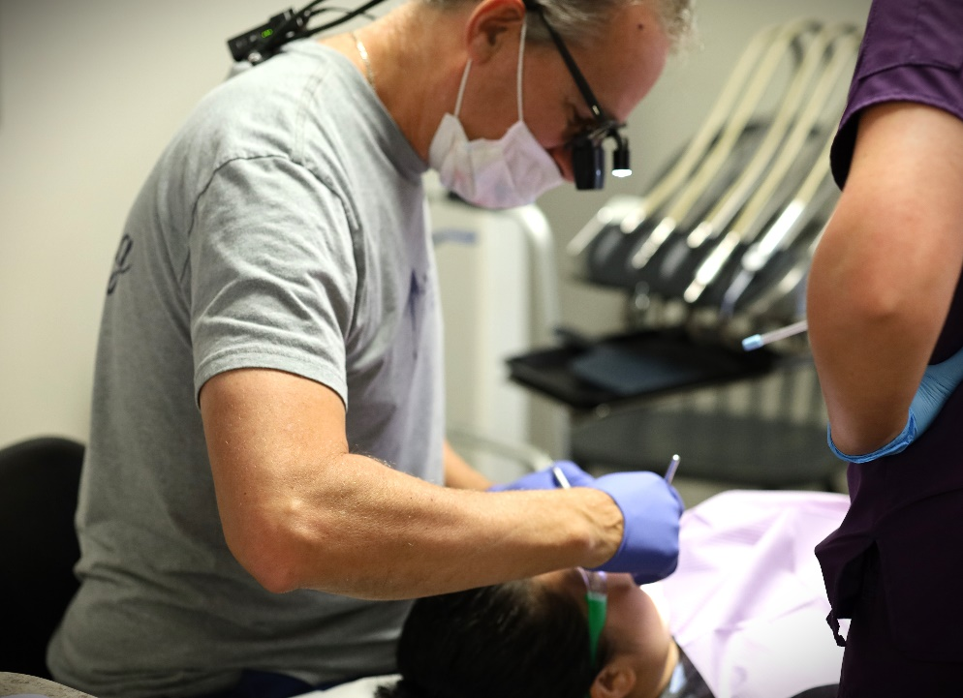
Ohlsson added, “This is such a rewarding experience for us and we couldn’t be happier to serve our community. Thank you to the VEC members who continue to contribute to VEC Customers Share.”

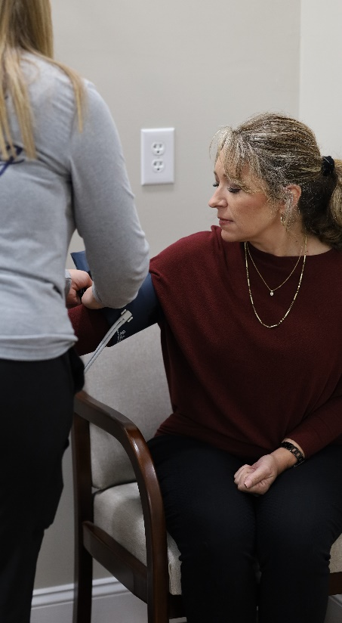
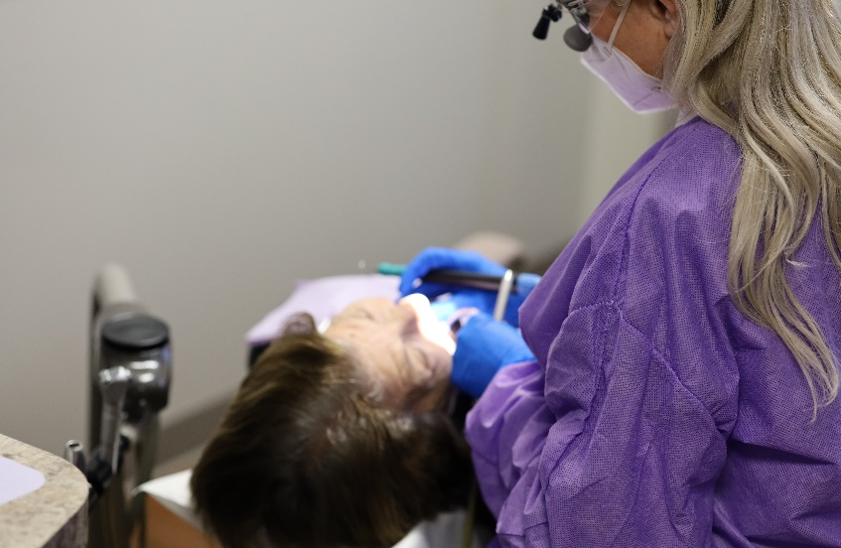
Karis Community Health serves 3,700 dental patients.
Karis Community Health provides services like check-ups and sick visits.
Dentist Dr. James Ohlsson has over 25 years of experience as a general health dentist in private practice and helped found Karis Dental with his wife, Kelly.

